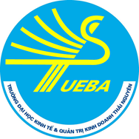 | THAI NGUYEN UNIVERSITY OF ECONOMICS AND BUSINESS ADMINISTRATION  Tan Thinh Ward, Thai Nguyen City, Vietnam  Website: http://en.tueba.edu.vn, Email: international@tueba.edu.vn  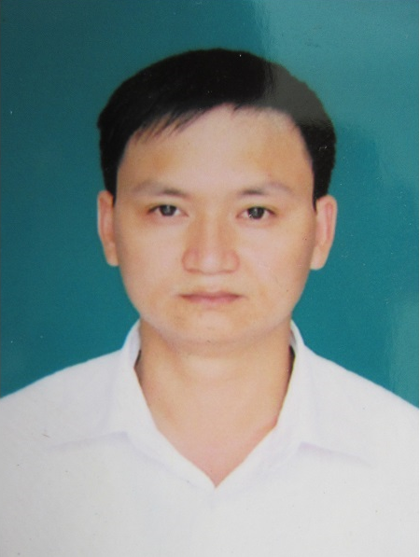

CURRICULUM VITAE

1. Personal information
Full name | PHAM VAN HANH
Academic title | Doctor
Date of birth | 11-02-1978
Gender | Male
Current address | Room 405, Main Building, COLLEGE OF ECONOMICS ANDBUSINESS ADMINISTRATION, THAI NGUYEN UNIVERSITY, Tan Thinh Ward, Thai Nguyen City, Vietnam
Mobile phone | +84-911220991
Email | pvha112@tueba.edu.vn
Position and workplace | DEAN of Faculty of Business Administration- Thai Nguyen University of Economics and Business Administration

2. Education background

2.1. Education progress
Year of graduation | Level |  |  | Major |  | Training institution
2001 | Bachelor Degree |  |  | Business Administration |  | Hanoi National Economics University, Vietnam
2005 | Master Degree |  |  | Business Administration |  | Hanoi University of Science and Technology, Vietnam
2014 | Doctoral Degree |  |  | Business Administration |  | Daegu University, Korea
2.2. Dissertation title |  |  |  | Why All Angry Customers Do Not Complain?  -The Mediating Role of Customer Emotion Regulation

2.3. Short-term training courses
Duration  (from date to date) |  |  | Training content |  | Training institution

2.4. Foreign language proficiency
Language |  | Level
English |  | Proficiency

3. Professional experience
Duration  (from date to date) | Workplace | Position or responsibility
2002-2004 | Thai Nguyen University of Tecnology | Teaching
2004-2008 | Thai Nguyen University of Economics and Business Administration | Teaching
2008-2010 | Thai Nguyen University of Economics and Business Administration | Vice Head of Division
2010 | Thai Nguyen University of Economics and Business Administration | Head of Division
2014-2016 | Thai Nguyen University of Economics and Business Administration | Associate Dean
From 2016 | Thai Nguyen University of Economics and Business Administration | Dean

4. Scientific research
4.1. Field of research
Expertise |  |  |  | Empirical Research in field of Human Resource Management, Marketing.
Main research orientation |  |  |  | - Emotional Labor,  - Customer Behavior  - Research with Moderated Mediation Analysis  - Emprical studies with SEM, Moderation, Mediation Model

4.2. Publications and accomplishments

4.2.1. Textbooks, Monographs
Year |  | Authors |  |  |  | Title |  |  |  | Publisher/ISBN
2016 |  | Pham Thanh Mai, Dong Van Dat, Pham Van Hanh |  |  |  | Project Management |  |  |  | Industrial and commercial publishers  978-604-931-188-8

4.2.2. Articles in national scientific journals
Year |  | Authors |  |  |  | Article title |  |  |  | Name of publisher, number, volume, pages/ISSN
2014 |  | Hanh, P. V., Hung, N. V., & Khanh, P. T. V. (2014) |  |  |  | The Effect of Emotional Intelligence and Social Norm on Customer’s Complaint Behavior |  |  |  | Economy and Forecast Review, Vietnam, No 4. 2014
2014 |  | Hanh, P. V. & Hue, H. T. |  |  |  | The Effect of Social Norm on Customer’s Complaint Behavior and Switching Intention |  |  |  | Thai Nguyen University-Science and Technology Review, Vietnam, No 10, 2014
2015 |  | Huy, N. V. & Hanh, P. V. (2015) |  |  |  | The Relationship among Service Quality, Customer Satisfaction, and Customer Loyalty at Hotels in Hanoi |  |  |  | Thai Nguyen University-Science and Technology Review, No 6, 2015
2015 |  | . Hanh, P. V., Hue, N.T., & Duong, L. Q. |  |  |  | The Effect of Employee Injustice on Customer’s Complaint and Switching Intention |  |  |  | Thai Nguyen University-Science and Technology Review, Vietnam, 2015
2016 |  | Hanh, P. V., Yen, D. T. H., Trang, H. T. T, |  |  |  | The model of cooperation between enterprises and households in n production, processing and consumption of medicinal plants |  |  |  | Thai Nguyen University-Science and Technology Review, Vietnam, 2016

4.2.3. Articles in international journals
Year |  | Authors |  |  |  | Article title |  |  |  | Name of publisher, number, volume, pages
2017 |  | Yoon, Mahn Hee  Pham Van Hanh |  |  |  | Does Angry Customer Immediately Complain? :A Moderated Mediation Analysis |  |  |  | Journal of Marketing Studies (Korean Strategic Marketing Association), Vol 25, No 1, 2017

4.2.4. National conference reports
Year |  | Authors |  |  | Article title |  |  | Conference name, Venue |  |  |  |  | Name of publisher, number, volume, pages

4.2.5. International conference reports
Year |  | Authors |  |  | Article title |  |  | Conference name, Venue |  |  |  |  | Name of publisher, number, volume, pages
2017 |  | Pham Van Hanh  Nguyen Thanh Vu |  |  | Should universities be considered as football clubs? The solutions to improve the training quality in future. |  |  | WORKSHOP ON Governance – Internationalisation- Quality Assurance: Challenges and prospects for universities in Vietnam and SEA

4.3. Research projects
Project duration |  |  | Project name |  |  |  | Funding institution |  | Funded amount |  |  | Position/role in the project
2014-2016 |  |  | Studying the cooperation model between farmers and enterprises in processing and selling medical products in mountainous area in Viet Nam |  |  |  | Thai Nguyen University |  | 2500 usd |  |  | Coordinator

4.4. Scientific research awards
Year | Award |  |  |  |  |  |  |  | Awarding organization

4.5. Other information on scientific research
Member of professional organizations and associations, editorial board of national and international journals, member of the national/international council ...etc.
Name of organization |  |  |  |  |  |  |  |  |  |  | Responsibility
Vietnam Economic Science Association of Agriculture and Forestry |  |  |  |  |  |  |  |  |  |  | Member

5. Teaching
5.1. Majors for teaching | Business Administration
5.2. Courses/modules can be taken | - Strategic Management  - Quality Management  - Small Business Management  - Research Methods in Business  - Econometrics

Applicant’s Institution | Thai Nguyen, June 1st, 2020  Applicant  Pham Van Hanh

